Week #12

Write a program that calls a method that throws an exception of type ArithmeticException……………Catch the exception and display appropriate message.
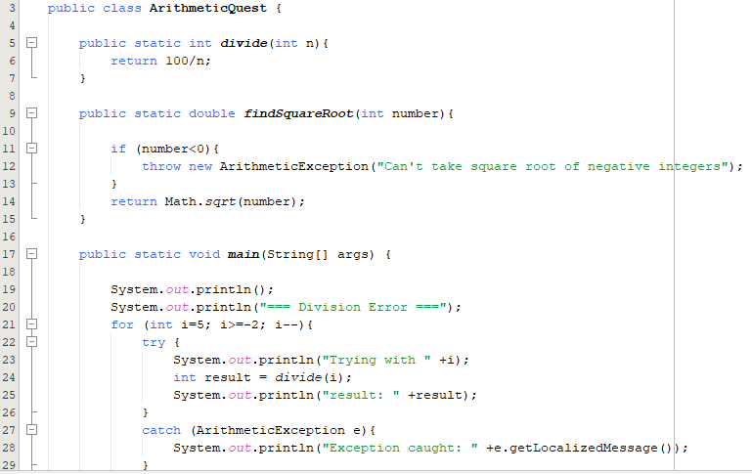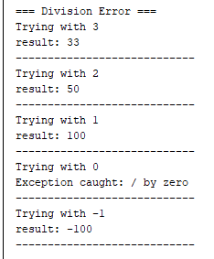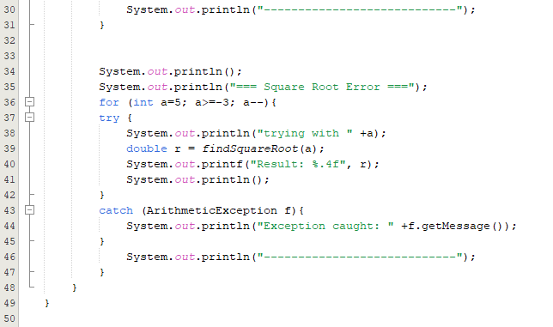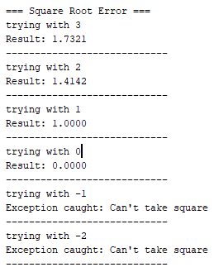

Write a program of your choice where a Checked Exception…………..using try-catch block and throws keyword.

You are developing an online banking system……………..an InsufficientFundsException should be thrown.
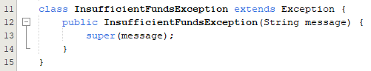
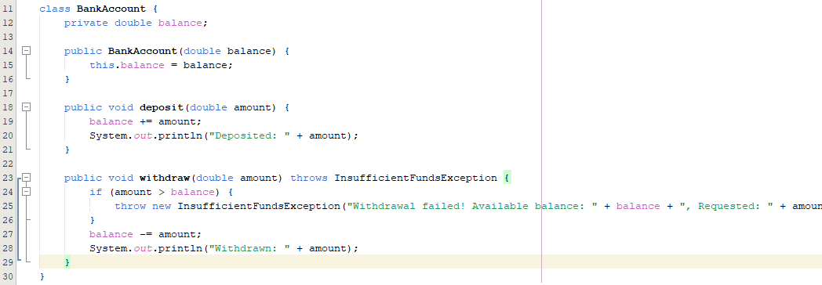
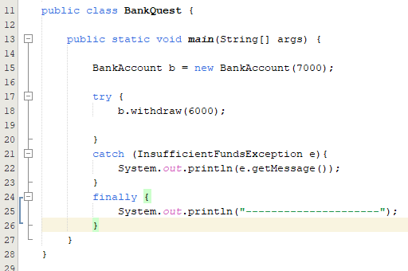

Create a user-defined exception InvalidAgeException when the age of a person is below 18 years. Use this exception at appropriate place.

